**PF LAB ASSIGNMENT 03:**

QUESTION#3

A customer asks the IT firm to develop a program in C language, which can take tax rate and salary from the user on runtime and then calculate the tax, the user must pay and the salary he/she will have after paying the tax. This information is then provided to the user.

#include <stdio.h>

int main(){

int salary;

printf("Please enter salary : \n", salary);

scanf("%d", &salary);

float tax_rate_percentage;

printf("Please enter Tax Rate Percentage : \n", tax_rate_percentage);

scanf("%f", &tax_rate_percentage);

float TR_s = (tax_rate_percentage * salary)/100 ;

printf("Tax due : %f \n", TR_s);

printf("Please clear all Tax Dues to receive Salary \n");

return 0;

}

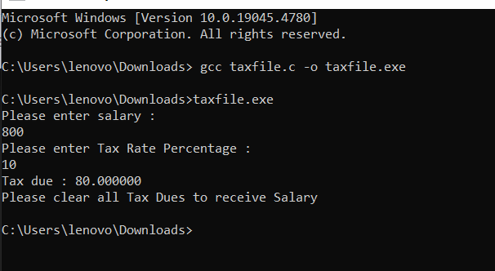

QUESTION #02 :

Write a C program that takes two integer values as input from the user. Then swap the value}

#include <stdio.h>

int main(){

int Num1;

printf("Input Num1 : \n");

scanf("%d", &Num1);

int Num2;

printf("Input Num2 : \n");

scanf("%d", &Num2);

int temp;

temp = Num1;

Num1 = Num2;

Num2 = temp;

printf("Num1 : %d \n", Num1);

printf("Num2 : %d \n", Num2);

return 0;

}

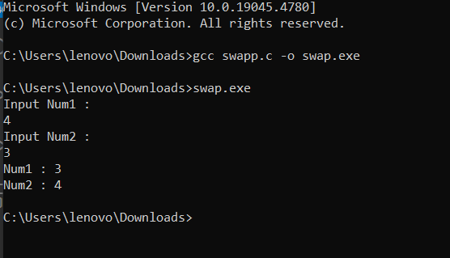

QUESTION #04 :

A car travelled back and forth from point A to point B. With a distance being (single trip) 1207KM. During the forward trip fuel price was 118/liter while returning it was 123/liter. Calculate the total fuel cost (both ways) and the fuel consumed (total trip). Use the car’s fuel average as input from the user (Input must be positive make some restrictions on only accepting positive input).

#include <stdio.h>

int main(){

int vfa;

printf("Enter Vehicle Fuel Average : \n");

scanf("%d", &vfa);

if (vfa>0) {

float onetrip = 1207/vfa ;

float way_forward = onetrip*118;

float way_back = onetrip*123;

float total = way_forward + way_back;

printf("Total cost for the journey is : %f", total);

}

else printf("INVALID INPUT PLEASE ENTER VALUES ABOVE 0. \n");

return 0;

}

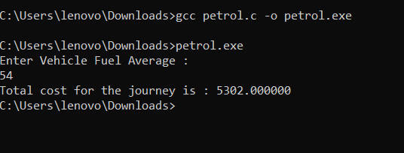

**Question 05:**

Construct a C program with the flowchart below. The input value of the principle must be between 100 Rs. To 1,000,000 Rs. The Rate of interest must be between 5% to 10% and Time Period must be between 1 to 10 years. Hint: these restrictions can be displayed in the form of message on the window.

#include <stdio.h>

int main(){

int period;

float rate;

float pa;

printf("Enter principal amount (BETWEEN 100 AND 1000000) : \n");

scanf("%f", &pa);

if (pa>100 && pa<1000000) {

printf("Enter rate (BETWEEN 0.05 TO 0.10) : \n");

scanf("%f", &rate);

printf("Enter TIME PERIOD (BETWEEN 1 TO 10 YEARS) : \n");

scanf("%d", &period);

float simple_interest = (pa * rate * period) / 100 ;

printf("Your simple interest is : %f", simple_interest);

}

else printf("INVALID INPUT \n");

return 0;

}

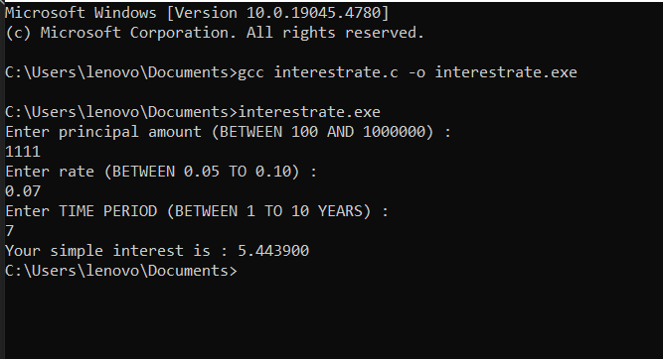

**QUESTION 6:**

Construct a C program where you calculate the slope of two point (5,4), (3,2). Use format

specifiers to cap the result to 3 decimal places.

#include <stdio.h>

int main(){

int x1 = 5;

int x2 = 3;

int y1 = 4;

int y2 = 2;

float slope = (y1-y2)/(x1-x2);

printf("slope : %.3f \n", slope);

return 0;

}

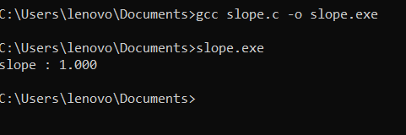

**Question 1:**

(maximum value for an int): 2147483647 on a 32-bit system.